**UAS1 vs UAS2 Detail Comparison Report**

**UAS1 Specifications:**

* CPU: Intel i7 6900k 3.20 GHz (8 Core)
* RAM: 128 GB DDR4 2133 MHz Non-ECC (G-Skill)
* HDD: Samsung EVO 850 1 TB
* GPU: nVidia Geforce GTX 1080 (8 GB)

**UAS2 Specifications:**

* CPU: (2) Intel Xeon E5-2680v4 2.40 GHz (14 Core ea., 28 Cores total)
* RAM: 128 GB DDR4 2133 MHz ECC (Kingston)
* HDD: Samsung EVO 750 500 GB
* GPU: nVidia Geforce GTX 1080 TI (11 GB)

**Passmark Benchmark Reports:**

* UAS1 Passmark Benchmark total = 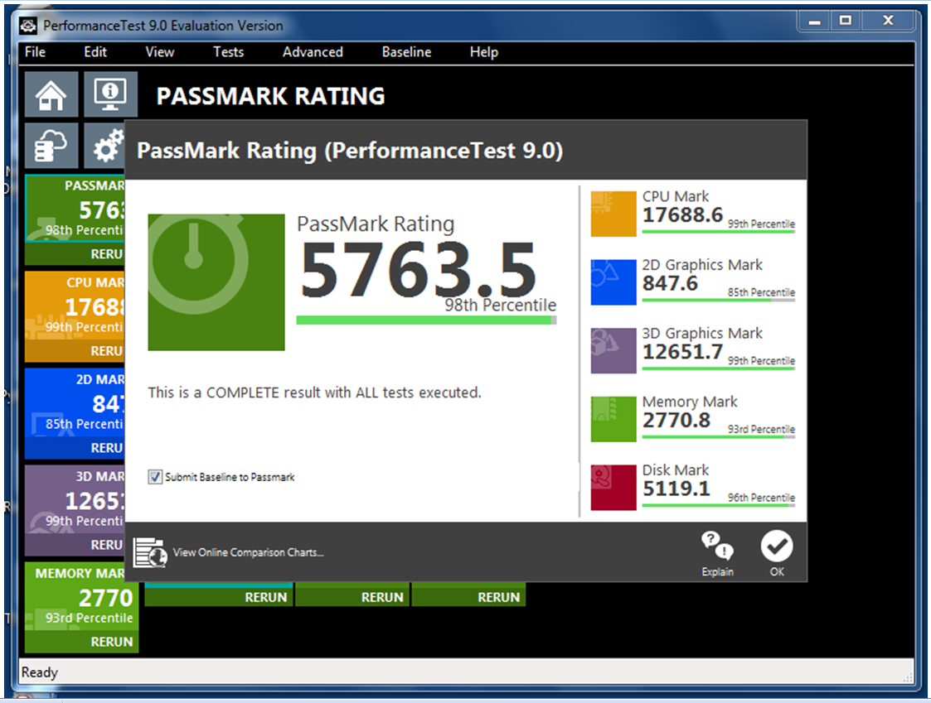
* UAS2 Passmark Benchmark total =

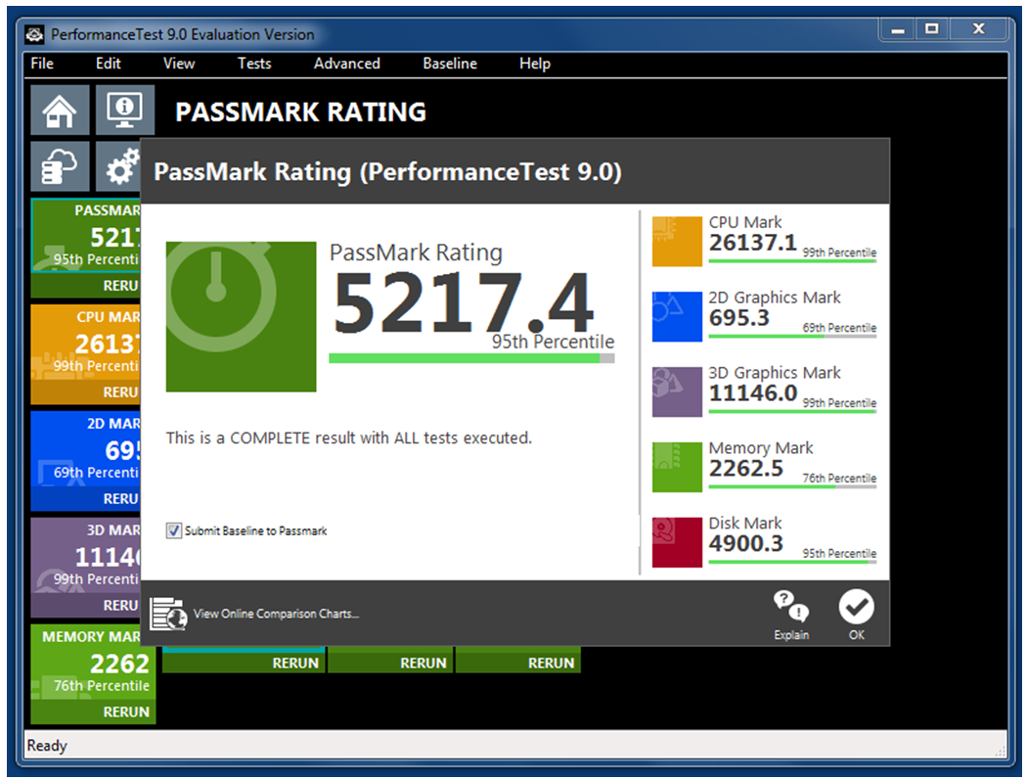

CPU Passmark Comparison:

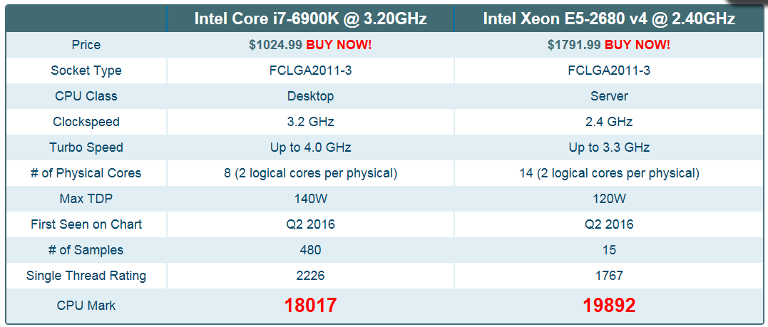

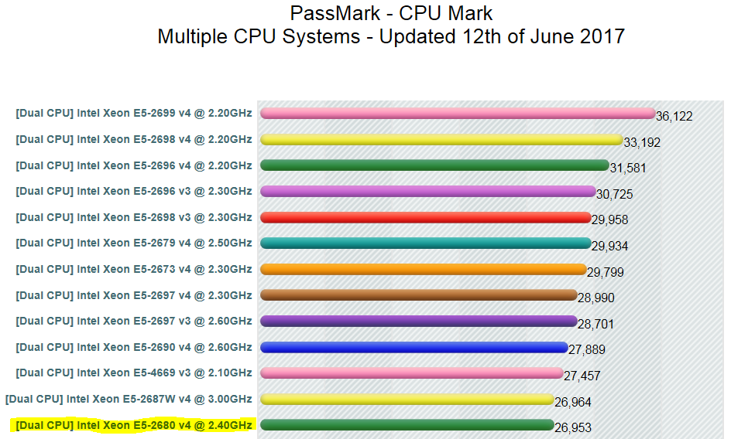

RAM Passmark Comparison:

* n/a

HDD Passmark Comparison:

* Samsung EVO 850 1 TB = 4413 Passmark (Overall rank 206)
* Samsung EVO 750 500 GB = 4141 Passmark (Overall rank 308)

GPU Passmark Comparison:

